

Bachelor of Computer Application (BCA) Programme

Minor Project Report

BCA Sem V

AY 2022-23

*Project Title: E-Voting System*

*by*

|  |  |  |
| --- | --- | --- |
| Exam No. | Roll No. | Name of Student |
| 4175 | 153 | Darshil T Prajapati |

**Project Guide by :**

Prof. Poonam Patel

*I N D E X*

|  |  |  |
| --- | --- | --- |
| **Sr. No** | **Description** | **Page No.** |
| 1 | Introduction |  |
|  | 1.1 Project description |  |
|  | 1.2 Project Profile |  |
| 2 | Environment Description |  |
|  | 2.1 Hardware and Software Requirements |  |
|  | 2.2 Technologies Used |  |
| 3 | System Analysis and Planning |  |
|  | 3.1 Existing System and its Drawbacks |  |
|  | 3.2 Feasibility Study |  |
|  | 3.3 Requirement Gathering and Analysis |  |
| 4 | Proposed System |  |
|  | 4.1 Scope |  |
|  | 4.2 Project modules |  |
|  | 4.3 Module vise objectives/functionalities Constraints |  |
| 5 | Detail Planning |  |
|  | 5.1 Data Flow Diagram / UML |  |
|  | 5.2 Process Specification / Activity Flow Diagram |  |
|  | 5.3 Data Dictionary |  |
|  | 5.4 Entity-Relationship Diagram / Class Diagram |  |
| 6 | System Design |  |
|  | 6.1 Database Design |  |
|  | 6.2 Directory Structure |  |
|  | 6.3 Input Design |  |
|  | 6.4 Output Design |  |
| 7 | Software Testing |  |
| 8 | Limitations and Future Scope of Enhancements |  |
| 9 | References |  |

**1. Introduction**

In democratic countries, voting is a vital tool to collect and re-act people views. In the elections, the election of member of the assembly, the head of local/state government election, and others, a voter can cast vote after going to the designated polling place and checking his identity. Conventionally, voting booth is used for casting votes in both centralized and distributed places. Voting is done under the supervision of authorized parties. Counting of votes is done manually once the election is over. But with the rapid growth of electronic voting system, computer technology and cryptographic methods can be used that substitute the occurrence and most significantly error-prone human Component. To increase the productivity and accuracy of voting processes, electronic voting systems were developed to help accumulating and counting the votes. It comprises Lever Voting Machines, Punched Cards for Voting, Optical Mark-Sense Scanners and Direct Recording Electronic (DRE) voting systems.

**1.1 Project Description**

An "e-voting " is an online website which provides the user, to give their votes through online. At the time of voting, a voter have to register themselves before voting their favourite candidates.

The main objective of the project on E-voting system is to save the time of the users by visiting their booth for voting. It manages all the information about the users and the group of candidates who are going to stand in the election. The purpose of the project is to build a system to reduce the manual work for managing the candidates at their booth and also to give high level security to the candidates. The aim is to automate its existing manual system by the help of computerized equipment and full-fledged computer software, fulfilling their requirements, so that their valuable data/information can be stored for a longer period of time with easy accessing.

**1.2 Project Profile**

|  |  |
| --- | --- |
| Project Title | E-Voting System |
| Definition : | E-voting systems are software platforms used to securely conduct votes and elections. As a digital platform, they eliminate the need to cast your votes using paper or having to gather in person. They also protect the integrity of your vote by preventing voters from being able to vote multiple times |
| Developed For : | SDJ International College, Vesu, Surat |
| Project Guide(s): | Prof. Poonam Patel |
| Front End: | Visual studio Code |
| Scripting language : | PHP |
| Back End : | Xampp Server |
| Operating System: | Microsoft Windows 8/10 |
| Tools used for ERD & DFD | Microsoft Word, Draw.io, Visio |
| Submitted By | Darshil Prajapati |

**2.Environment Description**

**2.1 Requirements**

* In the present system there are no such application level system provisions in the country to carry out the voting and procedure as a whole.
* Also in the present status, there is no such application in use for automated system for voting according to the voting structure existing in the country.
* All the step-by-step procedures are carried out by the authorized authorities according to the jobs assigned by the ECI.
* The fact is all the procedures are carried out manually, starting from the registration process to result publishing.
* The government to do this process manually wastes a lot of time and money. Thus the present system proves itself to be an inefficient one.
* The existing system is not web based.
* The user or person must want to go to the polling station for casting their votes.

**2.2 Technologies Used**

Software requirements:

|  |  |
| --- | --- |
| Browser | Microsoft Internet Explorer, Mozilla Firefox and Google Chrome |
| Operating System | Windows 10 and Windows 11 |
| Front End | Html, css |
| Back End | Php, mysql |
| Other Tools | - |

Hardware Requirements:

|  |  |
| --- | --- |
| Processor | AMD Ryzen 5 5500U |
| RAM | 4.00 gb |
| Hard Disk | 10 gb ssd |
| System Type | 64 or 32-bit Operating System |

**3. System Analysis and Planning**

**3.1 Existing System and its Drawbacks**

An [E-voting system](https://electionbuddy.com/features/online-voting/) is a platform that allows organizational members to cast their votes electronically, which can be through a website, mobile app, or any internet-connected device.

You can conduct various types of elections through an E-voting system. For example, you can use it for a simple majority vote, where the option or the candidate with the most votes wins. You can also use it for a more complex voting system like proportional representation, where each vote holds weight according to the voter’s preference.

Our online voting session goes like this:

* First, the voter logs in to the voting system using their mobile number and password.
* Next, they select the candidates or options they want to elect.
* Finally, they submit their vote, and the system tallies the results.

Disadvantages of E-voting system

* One of the most significant disadvantages of E-voting systems is that they’re not as secure as traditional paper-based systems because there’s always the potential for hackers to tamper with the results.
* Another disadvantage of online voting is that it can lack transparency. With traditional paper-based voting, voters can see people counting the ballots. But with online voting, the process is entirely electronic, making it harder to verify the results.
* The internet is a very vast network that requires a lot of expertise, time, and money to successfully monitor and disable all possible security threats. Political voting would be very tricky because even the smallest security flaw could be exploited, causing severe damage and consequences. Hacker could tamper with election results. Online voting makes it very hard to ensure 100% safety.
* It requires to build a correct database of users in advance.
* It’s a costly affair and a time taking process.

**3.2 feasibility Study**

* Elections differ not only from country, but also within each country. Some elections, like the US presidential elections, have very simple voting rules and ballots. Other elections, like local elections in India have very complex voting rules and ballots.
* Elections with complex voting rules and ballots introduce challenges regarding the vote casting and the tallying process. While mostly, software support for the tallying is in place, the vote casting process is rather error prone, as voting rules are very complex, and voters might unintentionally spoil their vote.
* In this work we analyses existing E-voting systems regarding their feasibility for the local election in India.
* An E-voting system would consist of an online voting application, a front-end system and a back-end system. The E-voting system would utilize some e-Identification, the voting register and the election information system.
* This would jeopardize the secrecy of online votes in the ballot box, as the vote and the voter's details would need to be stored together.

**3.3 Requirement Gathering and Analysis**

Requirement Analysis In the present system there are no such application level system provisions in the country to carry out the voting and procedure as a whole. Also in the present status, there is no such application in use for automated system for voting according to the voting structure existing in the country. All the step by step procedures are carried out by the authorized authorities according to the jobs assigned by the ECI. The fact is all the procedures are carried out manually, starting from the registration process to result publishing.

The government to do this process manually wastes a lot of time and money. Thus the present system proves itself to be an inefficient one. The existing system is not web based. The user or person must want to go to the polling station for casting their votes.

Functional requirement (Admin)

* Admin will be able to manage new applications, users, admins and candidates.
* He can perform insert, update and delete on above modules.
* Moreover, he can set the results date and also see the votes state-wise.
* He will be able to manage the voting result page as per declared result date.
* He can view and retrieve details of newly registered users from Aadhar table.
* Ensure that votes must not be associated with voter identity.
* Ensure that system operations are logged and audited.

E-voting system Functional requirement (User)

* He shall be able to vote from any system within the nation.
* User can apply for new Election Identity Card after legal age i.e. when his/her age is 18 or above. After application, a user will receive Election Card at his/her registered Address in Aadhar Card.
* A user only needs to enter his/her name and identity photo and password for new application.
* A user has to register with Election Commission to access partial functionality of the site.
* When user wants to vote, he needs to first login using his/her mobile number and password.
* A user will be able to link his aadhar card with election ID card so that the details of user gets updated in Election Card also.
* After a user has voted successfully, he/she won’t be allowed to vote again.
* The results will be shown under the results tab on the declared result date only.
* A user can check overall results of India as well as state-wise results also in chart form.

**4**. **Proposed System**

**4.1 Scope**

* The E-voting system is made for the people of the country residing around the world and wants to vote for their representative. The election can be conducted in two ways the paper ballot election and the automated ballot election.
* The automated ballot elections are called the electronic voting. The E-voting system is highly developed and the online polling system can be replaced by accurately and directly voting online and immediate results. The E-voting system is done by the internet so it can be called the Internet Voting also.
* The data of the voter will be stored in the database so that the voter cannot gives the vote multiple time.
* With the help of E-voting system the result will be given accurately rather comparing to ballot voting.
* Unlike traditional systems, online voting (e-voting) systems exploit computerized voting equipment, computer networks and cryptographic protocols to conduct elections.
* They possess the ability to merge both verifiability and ballot secrecy successfully at the same time, a combination that cannot be achieved by other means.
* Hence, elections conducted by e-voting systems are expected to be efficient, accurate, secure and convenient.
* However, potential problems associated with e-voting systems may degrade their acceptance.
* To establish e-voting systems as a reliable tool to conduct elections, already extensive research has been proposed. This paper proposes an analysis of existing e-voting schemes along with their scopes and limitations.

**4.2 Project Modules**

* To create a proper website there are different types of module which are required to be constructed.

1. Registration module
2. Login module
3. Group module
4. Voter module

**4.3 Module vise objectives/functionalities Constraints**

* Registration module

1. The main module among all is registration here you have to register yourself before you are ready to give your vote
2. It require some few details about the user like username, mobile number, address, password, confirm password and an image of your identity (eg. Pan card, Aadhar card).
3. If you are a voter then you have to register as a voter.
4. But if you are standing as a candidate then you have to apply as a group.

* Login module

1. After registration you will be directed to login page, where you have to fill details like you mobile number and password.
2. And to register as a voter or else want to see as a candidate.
3. The password which you have register at the time of registration should be matched with login password or else you won’t be able to login.

* Group module

1. If you are a candidate you have to register yourself as a group .
2. Here you can check your status and how many votes you have received.
3. The result is been stored in database so you cannot do any changes or you will be caught and can be suspended from the election.
4. Voter who receive the highest vote will be declared as a winner

* Voter module

1. If you are a giving a vote then you have to apply as a voter, then only you will be able to give a vote.
2. Once you gave a vote to your preferred candidate you won’t be able to change your vote, so you have to give your vote very precisely.
3. After giving vote you have to click on submit button then only your vote will be registered and will be counted.
4. You can give your vote only once, at the time of registration your identity and number will be checked.
5. If you are trying to give another vote then you be get penalized by the voting authority.

**4.4 Expected Advantages**

* One of the main reasons modern organizations switch to online voting is that they can give their voters the convenience of voting from anywhere, on any device. Since they are given a username and password to access their ballot, all they need is a secure network on which to cast their vote.
* By eliminating the use of physical post and manual vote counting you can avoid result-distorting mistakes such as loss of voting documents and miscounted votes.
* It is very easy and efficient as it take only 5-10 minutes to vote, as you won’t have to wait in a long queue.
* Switching to online voting can reduce your organization’s costs significantly. It saves you the price of printing and mailing thousands of ballots if you typically opt for mail in ballots.
* A simple miscount of a single vote can mean the wrong candidate wins. Online voting boasts security systems that ensure every vote is counted in real time. Ballot tracking documents click and open rates, and the exact moment a vote is processed.
* Traditional paper voting needs to supply paper ballots, postage and printing. Plus it requires extra manpower for counting votes through [show of hands](https://www.verovoting.com.au/blog/is-show-of-hands-worth-the-risk/).
* Thus, these are the expected advantages of E-voting system.

**5. Detail Planning**

**5.1 Data Flow Diagram / UML**

A Data Flow diagram (dfd) is a graphical or visual representation using a standardized set of symbol and notation to describe a business’s operation through data movement.

Dfd is made up of 4 main elements they are entity, process, data store, data flow.

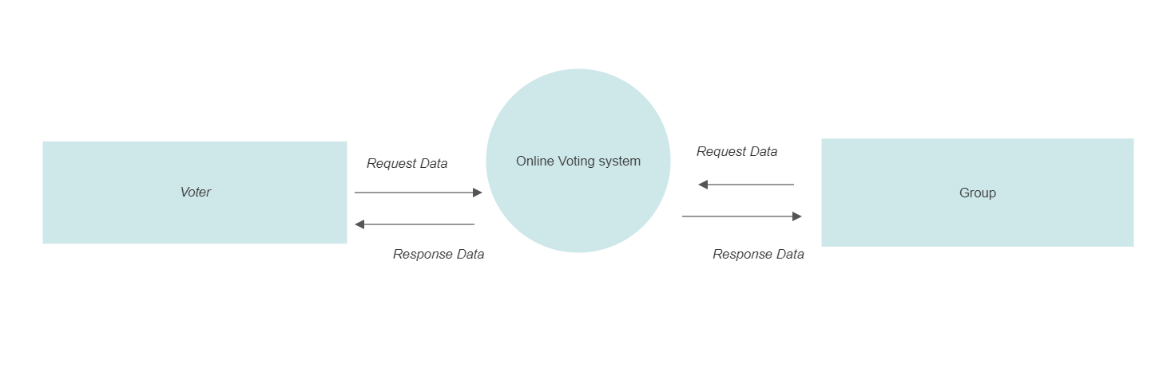

* Registration ( Voter/ Group)

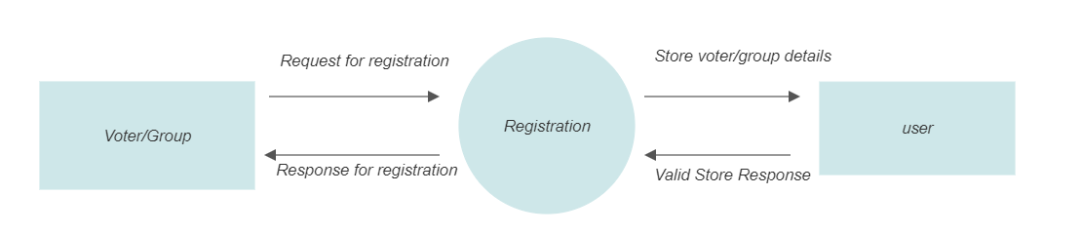

* Login (Voter/Group)

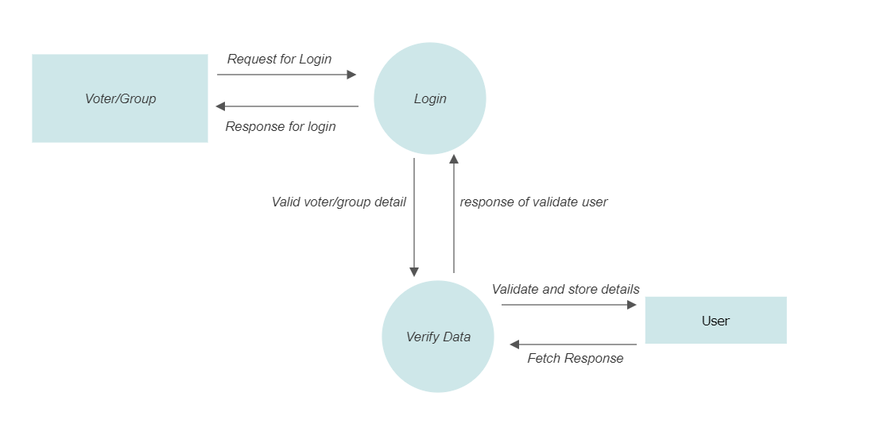

* Voter

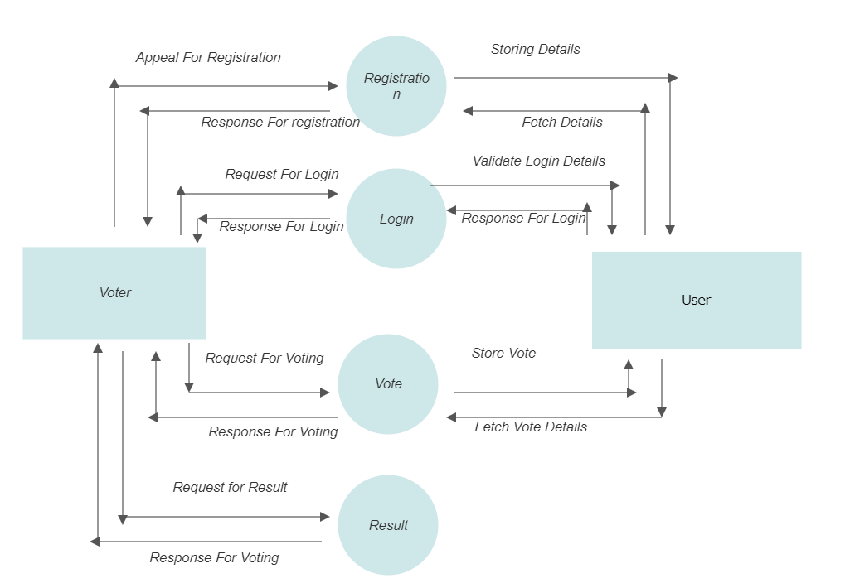

**5.2 Process specification/ Activity Flow Diagram**

Registration

Voter/Group

Login

Voting

Voting Report

Report View

**5.3 Data dictionary**

|  |  |  |  |
| --- | --- | --- | --- |
| Sr. No | Field name | Data Type | Constrain |
| 1 | ID | int(11) | Primary key |
| 2 | Name | text | Not null |
| 3 | Mobile | bigint(10) | Not null |
| 4 | Password | int(11) | Not null |
| 5 | Address | varchar(255) | Not null |
| 6 | Photo | varchar(255) | Not null |
| 7 | Status | int(11) | Not null |
| 8 | Votes | int(11) | Not null |
| 9 | Role | int(11) | Not null |

**5.4 Entity-Relationship Diagram / Class Diagram**

group

User Registration

Voter

User Login

1. **System Design**

**6.1 Database design**

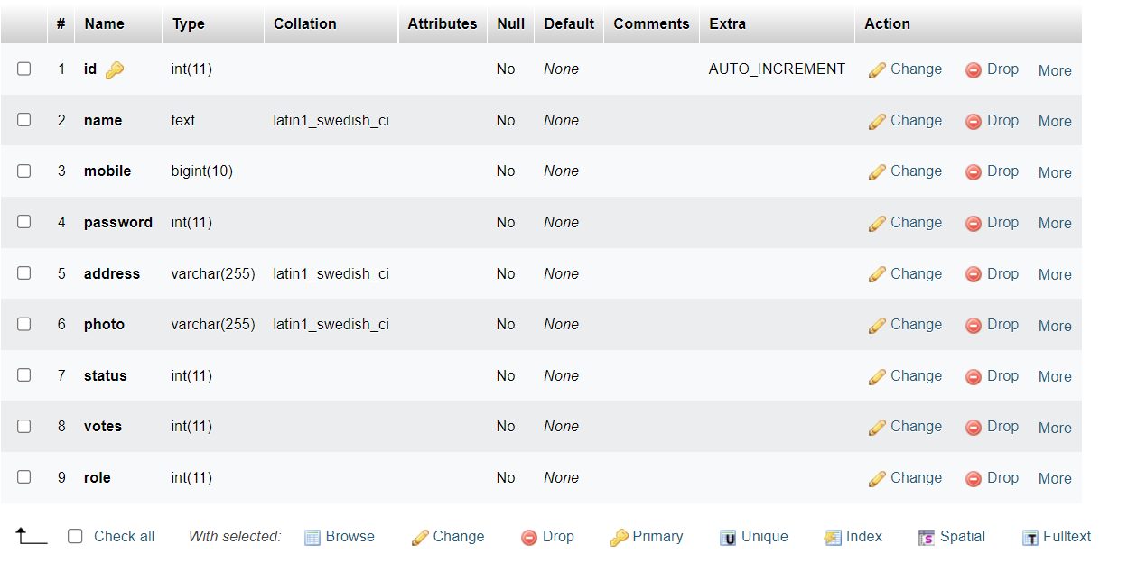



**6.2 Directory Structure**

E-voting-system

Routes

Index.php

Uploads

Api

Css

Connection.php

Register.php

Vote.php

Login.php

Dashboard.php

Register.php

Logout.php

**6.3 Input Design**

**Registration Page:-**

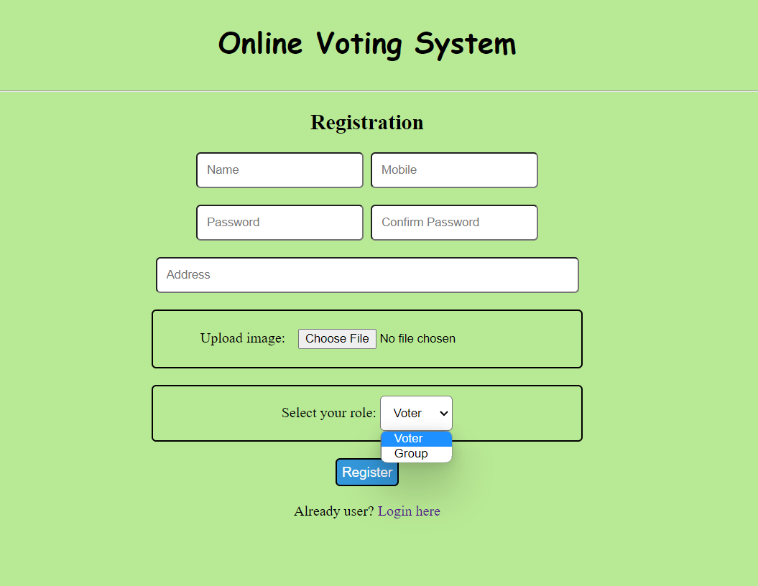

**Login Page:-**

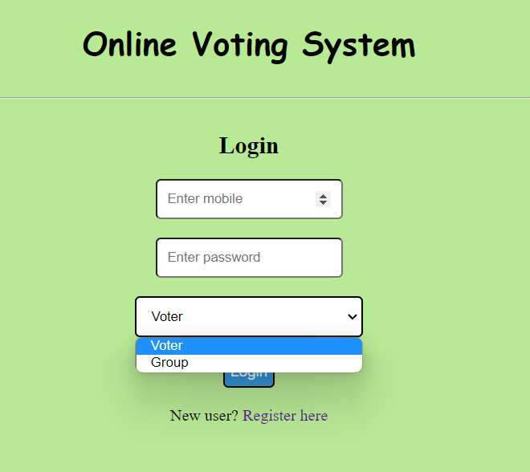

**6.4 Output Design**

**Voter Page:-**

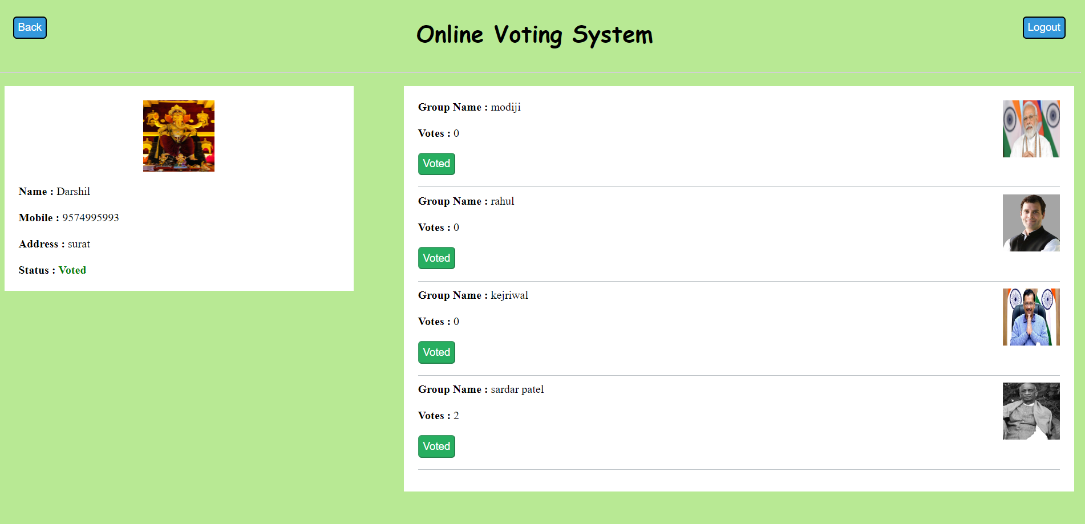

**Group(Candidate) Page:-**

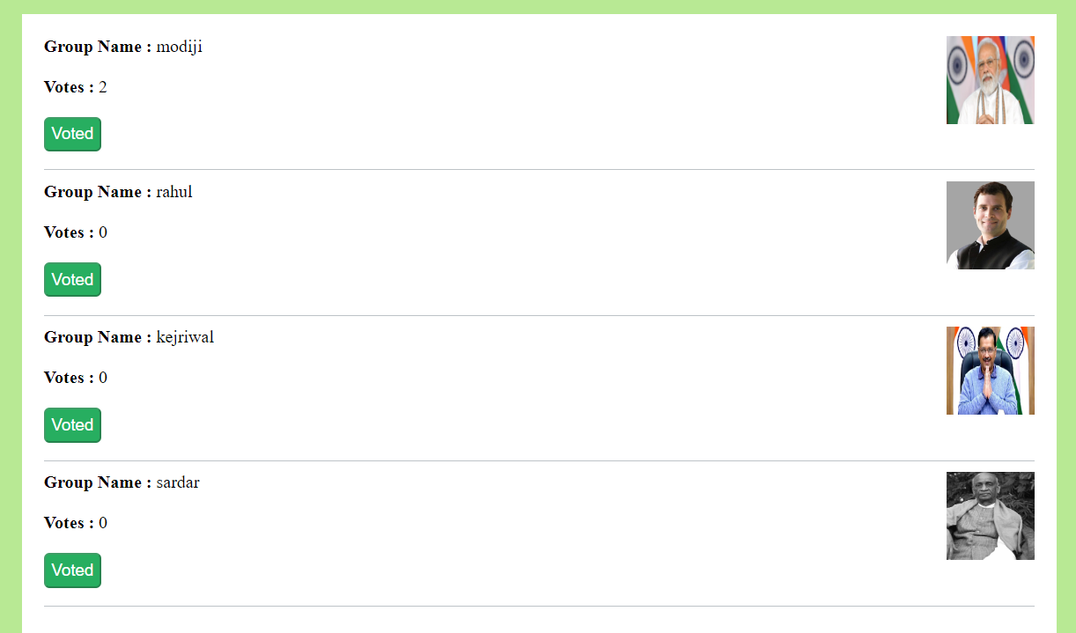

1. **Software Testing**

It needs to be thoroughly tested to ensure that every component of the system is operating as it should, and that the system is performing exactly in accordance with the specific local requirements.

* Functional Testing is a type of software testing where, the system is tested against the functional requirements/specifications.
* This type of testing is not concerned with how processing occurs, but rather, with the results of processing. Functions are tested by feeding them input & examining the output.
* Functional testing ensures that the requirements are properly satisfied by the application.
* Admin is able to add new candidates. And the changes of which will get reflected dynamically in Vote Collection table.
* Admin can now issue Voting Cards on based on the Applications received.
* Admin side upload image is working properly.
* Login & Password validation process has been co-operated properly.
* Visitor is able to register themselves.
* Voter can register using his/her Voter ID.
* Voter is able to vote anonymously.
* Voters will be able to vote only once.
* Old Users will be able to link Aadhar Card with their Election Card.
* Voters & group of candidates both will be able to see results on and after result dates.

**8 Limitations and Future Scope of Enhancements**

Limitations of E-voting system

* Not every election are a good fit as scalability can be the limiting factor.
* Some countries will accept while some not as they have to do according their by law issues.
* There is a risk of breaching of security.
* Political party may strongly oppose this new system in certain region.

Future scope of E-voting system

* The challenge of developing electronic voting systems is not only security but also protecting the secrecy of the ballot, a bedrock principle of free and fair elections. Currently there is “no known technology that can guarantee the secrecy, security, and verifiability of a marked ballot transmitted over the Internet.
* Online voting presents numerous vulnerabilities and is fundamentally insecure. There is potential for unobserved vote manipulation as well additional security vulnerabilities including potential denial of service attacks, malware intrusions, and privacy concerns.  Online voting does not produce a paper trail for auditing.
* End-to-end verifiable election software relies on cryptography to encrypt and protect votes while allowing voters to see their vote was properly recorded, that the vote was correctly tabulated, and that the final vote count matches the cast votes.
* This system can be used for election of university/college level since it can save time, increase flexibility if more security features are added to it.
* This can be easily modified as per guidelines as election process is in itself is dynamic.
* With more utilities provided various reports and useful results can be generated of importance.
* Trouble reporting and other added facilities can be added thereafter.
* E-voting system can be made more secure by adding features link password changing, fingerprint or cornea detection.
* It will increase the overall voting percentage.
* It will reduce election expenditure by adding more features in voting system.

**9. Reference**

* Website <https://www.w3schools.com/> for php, html, css standards.
* Website <https://www.tutorialspoint.com/>
* Website <https://www.youtube.com/>
* Website <https://app.diagrams.net/>